Ali YILMAZ

KN920i.e

17.02.2022

<!DOCTYPE html>

<html>

<head>

<meta charset="utf-8" />

<title></title>

HELLO WORLD

</head>

<body>

</body>

</html>

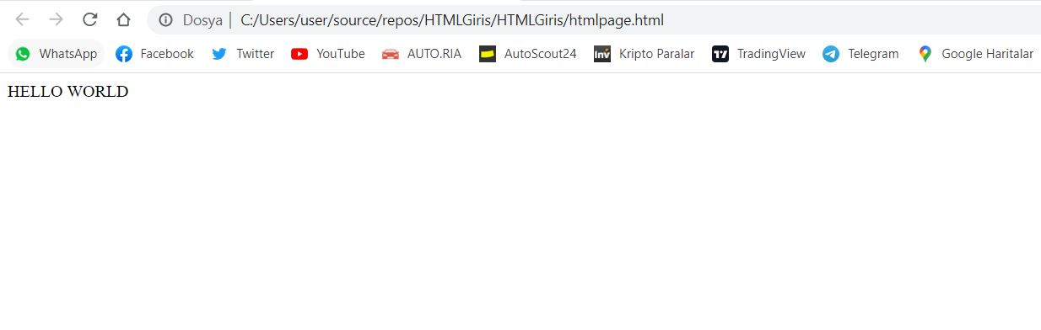

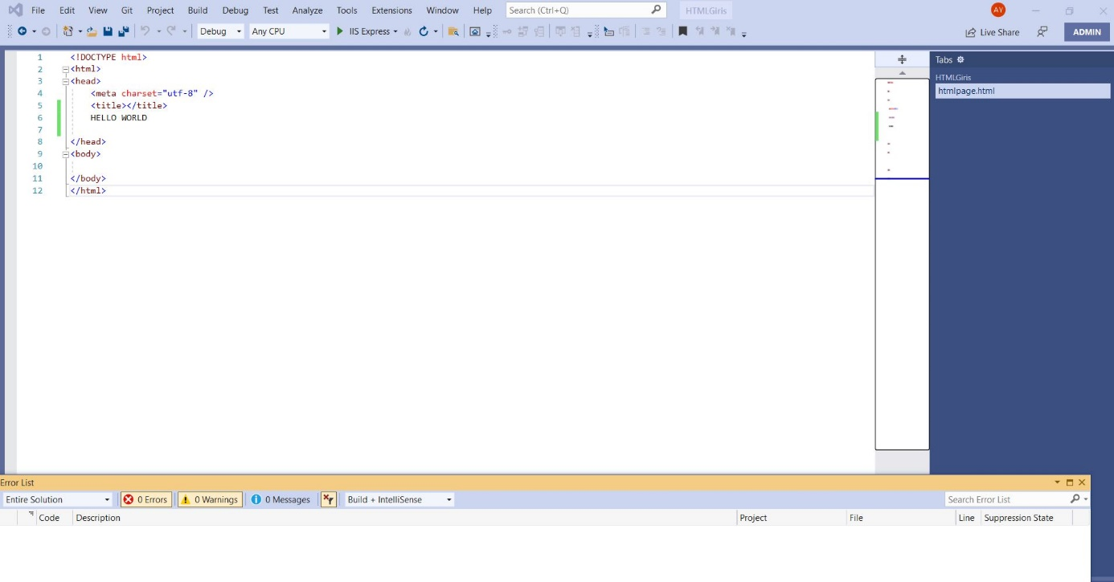

<!DOCTYPE html>

<html>

<head>

<meta charset="utf-8" />

<title></title>

HELLO WORLD

</head>

<body>

<p> <b> This Paragraph wrote Bolded </b></p>

<p> <strong> This Paragraph wrote stronged </strong></p>

<p> <i> This Paragraph wrote italik </i></p>

<p> <em> This Paragraph wrote stronged </em></p>

<p> <mark style="background-color: red;"> This Paragraph wrote stronged </mark></p>

</body>

</html>

